**3D plots**

In order to create a graph of a surface in 3-space (or a contour plot of a surface), it is necessary to evaluate the function on a regular rectangular grid. This can be done using the meshgrid command. First, create 1D vectors describing the grids in the *x*- and *y*-directions:

>> x = (0:2*pi/20:2*pi)';

>> y = (0:4*pi/40:4*pi)';

Next, ``spread'' these grids into two dimensions using meshgrid:

>> [X,Y] = meshgrid(x,y);

>> whos

Name Size Bytes Class

X 41x21 6888 double array

Y 41x21 6888 double array

x 21x1 168 double array

y 41x1 328 double array

Grand total is 1784 elements using 14272 bytes

The effect of meshgrid is to create a vector X with the *x*-grid along each row, and a vector Y with the *y*-grid along each column. Then, using vectorized functions and/or operators, it is easy to evaluate a function *z* = *f*(*x*,*y*) of two variables on the rectangular grid:

>> z = cos(X).*cos(2*Y);

Having created the matrix containing the samples of the function, the surface can be graphed using either the mesh or the surf commands (see Figures [8](http://www.math.mtu.edu/%7Emsgocken/intro/node21.html#mesh) and [9](http://www.math.mtu.edu/%7Emsgocken/intro/node21.html#surf), respectively):

>> mesh(x,y,z)

>> surf(x,y,z)

   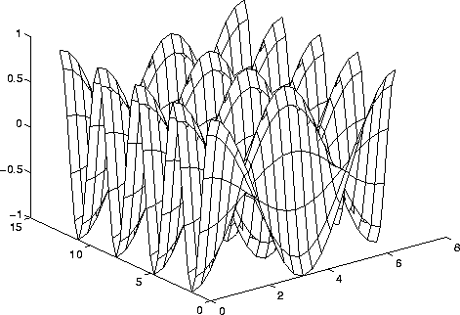  
**Figure 8:** Using the mesh command

   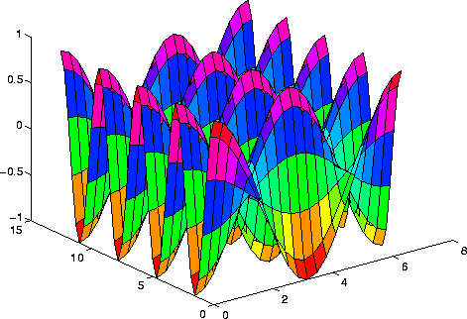  
**Figure 9:** Using the surf command

(The difference is that surf shades the surface, while mesh does not.) In addition, a contour plot can be created (see Figure [10](http://www.math.mtu.edu/%7Emsgocken/intro/node21.html#contour)):

>> contour(x,y,z)

   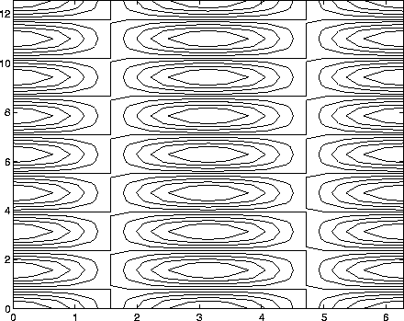  
**Figure 10:** Using the contour command

Use the help command to learn the additional options. These commands can be very time-consuming if the grid is fine.

*Mark S. Gockenbach   
Wed Sep 8 10:44:13 EDT 1999*